**The Freedom Park**

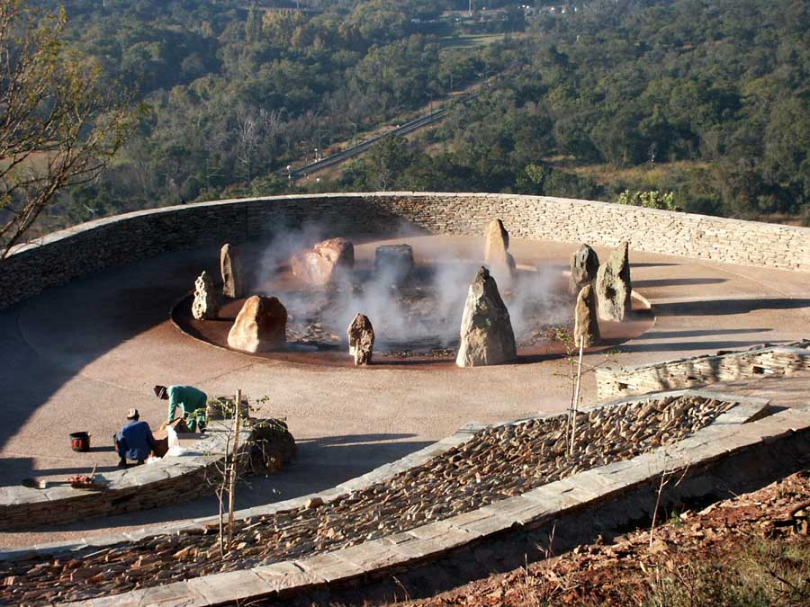

Driven by the necessity for the diverse people of South Africa and the world to understand and appreciate the country’s struggle for liberation, The Freedom Park was born as a national and international icon of humanity and freedom. The Freedom Park, with its Garden of Remembrance, is located on a 52-hectare site on Salvokop Hill at the entrance into Tshwane (Pretoria) from Johannesburg. The uphill climbs and winding roads serve a very symbolic purpose at The Freedom Park: it stands as a testimony to the arduous road that South Africans had to travel to reach their destination of humanity and freedom. Golf carts are available for the disabled and elderly. The Park is being constructed in phases and are currently busy with //hapo, an interactive space that will tell the story of the Southern African region dating back 3.6 billion years. //hapo will also house the official welcoming and reception area. The Wall of Names currently bears 75,000 names of those who died fighting for humanity and freedom in South Africa. The wall has space for 136,000 names to be inscribed. The Wall of Names is not constructed as a fait accompli and allows future generations to add the names of their deserving heroes and heroines.